BIOE 507 Quiz (Microscopy lectures) Due 04/27/21

1. Define Raleigh scattering. Show the relevance of Raleigh Criterion in spatial resolution.

Rayleigh scattering is elastic scattering of light by particles much smaller than the wavelength of the light. The Rayleigh criterion specifies the minimum separation between two light sources that may be resolved into distinct object. It determines the diffraction limit to resolution by θ=1.22λ/D, where θ is the minimum angle between distinguishable point sources, λ is the wavelength of light and D is the diameter of the lens. In order to increase spatial resolution of imaging, light with smaller wavelength or larger lens is desired.

1. Slide 5: Explain the Jablonski Diagram (showing the key states).

Jablonski diagram illustrates the energy state of a molecule and transitions between them. The first step is absorption. An electron of the molecule is excited from a ground state energy level to a higher energy level by transferring the energy from a photon with specific wavelength. The transition is very fast, on the order of 10^-15 seconds. The second step is internal conversion. After the electron is excited to second excited state (S2), it can transition from a vibration level in one electronic state to another vibration level in a lower electronic state to first excited state (S1) by dissipating energy through vibrational relaxation. It takes less than 1 ps. Next, the molecule could deal with the received energy by emitting a photon and the electron jumps from S1 to ground state (S0). This process is called fluorescence and takes 1 to 10 ns. The energy of the emitted photon is less than that of the exciting photon. Yet, another way to dissipate energy from S1 state is intersystem crossing. The electron changes spin multiplicity from an excited singlet state (S1) to an excited triplet state (T1). It takes several ns to ms to complete. Then phosphorescence could occur by emission of photon when the electron transitioning from T1 state to ground state (S0). This process is very low, taking from several us to even > 1s.

1. Define the following in 2-3 sentences: quenching, photobleaching, ground state, ground state, excited state, radiative decay

Quenching: a process that decreases the fluorescence intensity. In fluorescence microscopy, Fourier resonance energy transfer (FRET) transfer energy from a donor to an acceptor which emits quenched photons with lower energy.

Photobleaching: the fluorophore molecule is unable to fluoresce permanently caused by alteration of structure after high-intensity illumination.

Ground state: all electrons of a molecule are in the lowest-energy state.

Excited state: molecule in the state with energy greater than the ground state.

Radiative decay: an molecule transitions from an excited state to a lower energy state, including the ground state, and emits photons.

1. Explain the basis of excitation and emission in fluorescence microscopy – Draw a simple excitation and emission spectra for a blue (or green or red) fluorophore (assume excitation and emission peaks as appropriate).

In fluorescence microscopy, Mercury/Xenon arc lamp is used as light source, which has several spectral intensity peaks at certain wavelengths. Light with specific wavelength is produced by passing the multispectral light from the excitation source through a wavelength excitation filter, because the fluorophore of the specimen could only be excited by a light with certain wavelength. Ultraviolet, blue or green light is often used. Then the specimen is irradiated with the filtered light to be excited. In order to achieve maximum fluorescence intensity, a fluorophore, whose excitation wavelength is near the peak of the excitation source, is usually choose. When the electrons relax from the excited state to ground state, some energy is lost due to vibrational relaxation. So the emission spectrum is shifted to longer wavelengths and its intensity peak has lower magnitude. This phenomenon helps separation of excitation light and emission light. Usually the widest possible wavelength that include the emission peak are selected for detection. Before observing in the detector, the light is filtered by the emission filter to remove light of different wavelength as the emission light.

For blue fluorophore with excitation wavelength at around 490nm, as shown in below, the blue line indicates the excitation spectra and the green line indicates the emission spectra with wavelength at 525nm.

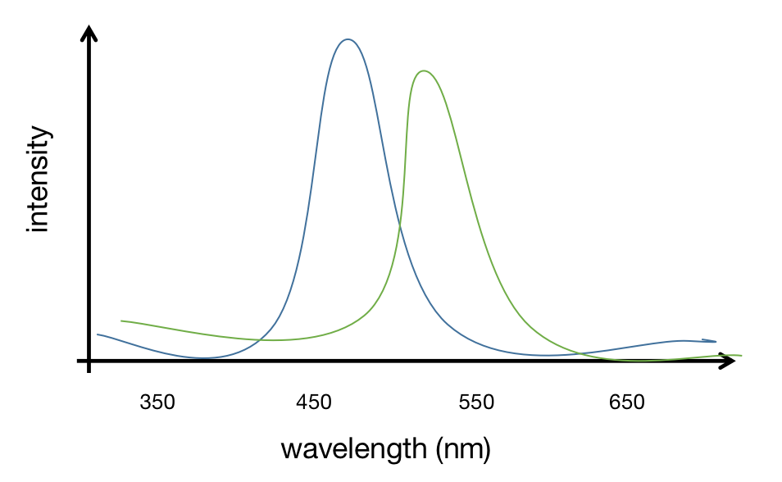

1. Slide 9: What is a point spread function (PSF) – what is the mathematical basis for PSF.

Point spread function is diffraction of light that blurs out point-like object to a certain minimal size and shape. It is the impulse response of the imaging system to a point source. In microscopy, the the image formation process is linear in the image intensity. The image is computed as a sum of PSF of each point, a process called convolution. After knowing the PSF, it could be restored to original object via deconvolution.

1. What is the underlying principle behind two-photon microscopy.

The two-photon microscopy is excited by absorbing 2 low-energy photons of high wavelength. Since the excitation needs simultaneous hit of 2 photons, higher photon densities are needed to increase the likelihood of excitation, which are achieved by concentrating photons in both space and time. Normally, the excitation only occurs at the focal plane and doesn’t generate out-of-focus fluorescence, reducing the background noise and requiring no pinhole for filtering unwanted light for detection. This mechanism provides less photo-damage, deeper penetration and better photon collection efficiency.

1. What is Fluorescence lifetime and how is it measured.

Fluorescence lifetime is the average time a fluorescent molecule remains in the excited state before going back to the ground state by emitting a photon. It’s sensitive to the fluorophore concentration, excitation intensity, photobleaching, and dynamics of microenvironment like PH and ion binding.

It can be measure in time domain and frequency domain. In time domain, its value decays exponentially as I(t)=I0*e^(-t/τ), where I0 is the initial fluorescence intensity, τ is the lifetime. After excitation by a short pulse of light, the photon intensities along time could be recorded and the lifetime τ could be calculated.

In frequency domain, time domain data is converted to frequency domain data via Fourier transform. The incident light is sinusoidally modulated at high frequency, then the emission photons have same frequency but with a phase delay (φ) and change in magnitude (m). The lifetime could be computed in both ways and they should be identical ideally (τ_p=τ_m=τ). τ_p = tanφ/ω, τ_m = (√(1/m^2-1))/ω, m=(AC/DC)emission/(AC/DC)excitation, where ω is light angular modulation frequency, φ is the phase delay, m is the demodulation ratio.

1. What is super-resolution microscopy and why is it called “super-resolution”. Discuss this in the context of confocal resolution.

In confocal microscopy, its lateral resolution is defined as d=λ/2NA, where λ is the emission light wavelength and NA is the numerical aperture of the objective. So the resolution is determined by the diameter of the airy disc and light wavelength, that is said to have a theoretic minimum value called diffraction limit.

Super-resolution microscopy is a kind of optical microscopy that allows images to have resolutions high than diffraction limit, beyond the a physical barrier that restricts the optical resolution to roughly 150nm due the the diffraction of light.

1. What are the 3 main types of super-resolution microscopy – discuss the basic principles that differentiate these three options (5-10 lines for each description)

Stimulated emission depletion (STED):

STED selectively deactivates the fluorescence in specific regions of the sample while leaving the center focal spot active to emit fluorescence, so that the point-spread function of the center excitation beam is narrowed to increase the resolution. The system has double laser design, where the inner excitation light is surrounded by the depletion light in a donut shape. The fluorescence emission process is interrupted in STED by the depletion light. The excited electron is forced to relax into higher vibration state rather than the fluorescence transition. The lowing energy causes the photon to be red-shifted. The shift differentiates the two type of photons, allowing the stimulated photon to be ignored. To force the alternative emission to occur and suppress the fluorescence, the incident light should have photons of high intensity.

Photoactivated localization microscopy (PALM)/Stochastic optical reconstruction microscopy (STORM):

In order to distinguish emission from the two neighboring fluorescent molecules, fluorescence blinking, a phenomenon of random switching between bright and dark states of the emitter under continuous excitation state, is utilized to obtain a stochastically sparse subsets of the fluorophores with light of specific wavelength. After photoactivation, the centers of the molecules is localized on the imaging containing just a few active isolated spots. To avoid the accumulation of active fluorophores in the sample, photobleaching is applied to deactivate all excited molecules. Repeat the cycle to get a large sequence of images with sparse activate spots to reconstruct the original objective. During each cycle, the density of the activated molecules is low enough to avoid overlapping of neighboring molecules.

Expansion microscopy (ExM):

It identifies small structure by expanding the underlying sample using a polymer system. The introduction of polymer network into samples and then physically expand the polymer network using chemical reactions could increase the size of the biological structures. The expansion has 4 steps: 1) staining; 2) linking: add a polymer gel to cells and link the fluorophores to the gel. 3) digestion: add solution to digest the cell and remove the structure from the cell. It guarantees the cell could be expanded uniformly without cracking; 4) expansion: physically expand the gel in all directions and the attached fluorophores expand as well.

1. What is fluorescence lifetime? what are its unique advantages over fluorescence intensity. What is the Phase change and modulation change in the context of fluorescence lifetime.

Fluorescence lifetime is the average time a fluorescent molecule remains in the excited state before going back to the ground state by emitting a photon.

Fluorescence lifetime is an intrinsic property of a fluorophore. Unlike fluorescence intensity, it is insensitive to fluorophore concentration, excitation intensity, and some extent of photobleaching. It could be affected by dynamics of microenvironment like PH and temperature and dynamics of molecules.

When measuring fluorescence lifetime in frequency domain, the excitation light is sinusoidally modulated at high frequency, then the emission photons have same frequency but with a phase delay and decrease in modulation which is related to the magnitude of the wave.